**Prosiding**

**Seminar Nasional Inovasi pendidikan dan Pembelajaran**

**Fakultas Pendidikan Bahasa dan Seni**

**IKIP PGRI Bojonegoro**

*Tema “Inovasi pendidikan dan Pembelajaran di era digital untuk Pengalaman Belajar*

*Imersif”*

**The Implementation of Differentiated Learning on English Students Interest of Grade XI at SMA N 1 Kedungadem**

Ahmad Nurul Mustofa1(🖂), Meiga Ratih Tirtanawati2, Chyntia Heru Woro Prastiwi3

1,2,3Pendidikan Bahasa Inggris, IKIP PGRI Bojonegoro, Indonesia

[21120046@ikippgribojonegoro.ac.id](mailto:21120046@ikippgribojonegoro.ac.id)

**Abstract—**This study aims to analyse the implementation of differentiated learning on English learning interest of grade XI students at SMAN 1 Kedungadem. This approach is based on Merdeka Curriculum which emphasises student-centred learning, taking into account differences in readiness, interests, learning styles, and abilities of each learner. The method used is descriptive qualitative with data collection techniques through observation, interviews, and questionnaires. The results show that teachers have implemented differentiated learning by providing a wide selection of media and learning strategies. Based on the analysis of learning interest questionnaires filled out by 30 students, the results show that 93% of students have a very high interest in learning English lessons. Supporting factors for increasing learning interest include flexibility in learning, providing constructive feedback, and a conducive learning environment. Thus, differentiated learning is proven to be able to increase students' interest in learning and can be used as an effective strategy in implementing Merdeka Curriculum.

**Keywords—**Differentiated Learning, Learning Interest, English, Merdeka Curriculum, High School Students

**Abstrak—**Penelitian ini bertujuan untuk menganalisis implementasi pembelajaran berdiferensiasi terhadap minat belajar Bahasa Inggris siswa kelas XI di SMAN 1 Kedungadem. Pendekatan ini didasarkan pada Kurikulum Merdeka yang menekankan pembelajaran yang berpusat pada siswa, dengan mempertimbangkan perbedaan kesiapan, minat, gaya belajar, dan kemampuan masing-masing peserta didik. Metode yang digunakan adalah kualitatif deskriptif dengan teknik pengumpulan data melalui observasi, wawancara, dan angket. Hasil penelitian menunjukkan bahwa guru telah mengimplementasikan pembelajaran berdiferensiasi dengan menyediakan berbagai pilihan media dan strategi pembelajaran. Berdasarkan analisis angket minat belajar yang diisi oleh 30 siswa, diperoleh hasil bahwa 93% siswa memiliki minat belajar yang sangat tinggi terhadap pelajaran Bahasa Inggris. Faktor pendukung peningkatan minat belajar antara lain adalah fleksibilitas dalam pembelajaran, pemberian umpan balik yang membangun, serta lingkungan belajar yang kondusif. Dengan demikian, pembelajaran berdiferensiasi terbukti mampu meningkatkan minat belajar siswa dan dapat dijadikan strategi efektif dalam penerapan Kurikulum Merdeka

**Kata Kunci—**Pembelajaran Berdiferensiasi, Minat Belajar, Bahasa Inggris, Kurikulum Merdeka, Siswa SMA

**INTRODUCTION**

Education has an important role in developing the potential and character of individuals to be able to face the challenges of life. When there is high-quality education available, the general public will become more aware. According to (Ariyani 2024) education is a process of life that aims to develop and enhance all of the potential that each person possesses within themselves so that they can live their lives and be able to contribute to their lives in a positive and constructive way so that they can grow into individuals who are able to learn. Every person has to learn a lot of things to help them grow, such as other languages, especially English, which is an international language. As time goes on, generations of people are being discouraged from using English as a communication tool. In the future, they will encounter many opportunities that will arise if people are able to communicate in English. The process is not easy, but it is not a slow way to get the results. This is because education is a savings or investment that will provide results when people can do things in their own time and contribute to the development of the nation and the country.

Therefore, the Indonesian government often modifies the school curriculum in order to accommodate the existing conditions and circumstances (Purba et al. 2021). The quiz is made with the aim of being one of the tools and also used as a reference for education implementers is the process of organeducational programme that provides students, teachers and parents with the knowledge and skills they need to innovate independently. It can be implemented by every student who acts as a teacher. It is expected that this curriculum can be implemented well or student-centred, by evaluating students' potential, ability and willingness to learn so that the learning process becomes more efficient. This curriculum has been implemented at SMAN 1 Kedungadem. This independent curriculum has learning objectives that are offered under the name of differentiated learning.

Carol A. Tomlinson, a teacher since 1995, discusses and explains their beliefs and identities in a book entitled ‘How to Differentiate Instruction in Mixed Ability Classrooms’. The book discusses ways of teaching that emphasise the differences that exist in each student. Furthermore, this approach is known as differentiated teaching or, alternatively, differentiated learning. Differentiated education is one of the solutions in education to meet the needs of students. According to (Herwina 2021) Differentiated learning is an effort or process carried out in order to meet learning objectives in educational activities in the classroom with the aim of meeting the learning needs of each student.Thus, each student present in the classroom has a different background of abilities and interests that can be learnt effectively so that learning objectives can be met. The process of educational differentiation is carried out with the aim of assessing and evaluating the learning needs, learning styles and motivations of each student. Educators have a strong desire to facilitate and improve the learning process in order to achieve the desired educational goals. It is important for teachers or students to have the ability to guide the learning process according to each student's unique needs, preferences and characteristics (Purba et al. 2021).

Different education is not a new concept in the field of education. One of the key points to look out for in different education is the need to understand the needs of students and provide appropriate guidance to help them achieve their learning goals. Observations made in this laboratory show that different teaching methods can be said to have achieved the desired results in increasing students' interest in learning English. This can be seen from the interest and enthusiasm of students in general during teaching and learning activities that teach English as a second language in the classroom.

**RESEARCH METHODS**

The research conducted used qualitative methods. The qualitative method is a research approach that is based on literature and is used during the research process in an experimental setting where the researcher or author of this article acts as an instrument. Methods for collecting data and analyse it qualitatively filters are more straightforward and in-depth (Sugiono 2020). Perhaps the main purpose of this qualitative research is to create and provide information or statements that are easy to understand according to their model, which can develop new hypotheses (Fiantika, Wasil M, Jumiyati, Honesti, Wahyuni, Jonata 2022).

This researcher used data and information collection techniques through observation, questionnaires, and interviews. The purpose of using these techniques is to collect comprehensive and accurate information in which the researcher engages in long-term conversations with respondents to obtain data relating to the process of teaching English as a foreign language using different teaching approaches. The school used as the object of this observation was SMAN 1 Kedungadem, and the research period lasted for 10 days, starting on 5 May 2025, and ending on 14 May 2025.

**RESULTS AND DISCUSSION**

1. **The implementation Of Differentiated Learning**

In the implementation of the diversity education programmet at SMAN 1 Kedungadem, educators have taught the material by taking into account the readiness level, interests, abilities, and learning styles of each student. As a basis for planning learning activities, awareness of student differences and diversity can be characterised as teaching with creative teachers. Educators can also become more creative by making the learning environment more interesting and improving the process, product or outcome of English language learning. The purpose of differentiated education that has been implemented in schools is to help students in the learning process because students do not need to always be on the same page as other students in every aspect of their education. During teaching and learning activities, the teachers of SMAN 1 Kedungadem will provide several learning strategies that will be evaluated by the students based on their interest, readiness, and learning style. For example, in teaching-learning activities, the instructor will provide learning materials through audio and video as well as modules. The instructor will still use both learning resources, but students can follow the learning activities according to their own choice. This is because each student has his or her own ability to learn. Some learn English more effectively by watching videos and listening to audio, while others learn English more effectively by reading.

Understanding student learning readiness is an important concept for every teacher or student in a diverse learning environment. If a teacher has a good understanding of the student's learning style, then the teacher can help students provide positive comments on the new learning material that will be taught so that the teaching and learning process can run smoothly. Through teacher differentiation, this school also consistently evaluates and assesses students with the aim of understanding and guiding learning activities so that students are more responsible. Each teacher can adapt this differentiated learning into the classroom according to three main elements, namely the curriculum and the material to be taught according to the learning method. Second, the process by which students gather ideas and information so that they can determine the right learning method. Because there are many different learning styles taught to students, the classroom needs to be modified in such a way that learning needs can be met effectively. The third product is the output or end result of the learning process which is characterized by diversity. Every English teacher at SMAN 1 Kedungadem has a different teaching method. There is certain material that focuses on the process, product, or learning environment itself. However, expectations and reality are not the same, the teacher has taught students very well and in accordance with the curriculum. Teachers are also very disciplined in their teaching methods. They will be guided by the schedule that has been set. On the other hand, it is seen that students' motivation in learning English is quite high. Not many students protest when the teacher does this, then there are students who are a bit hesitant when the teacher explains English material in class, the learning environment is very conducive, and students are always present when teaching and learning activities take place. Therefore, the goal of this differentiated education can increase students' interest in learning English. Seeing the current situation, teachers of SMAN 1 Kedungadem continue to strive to make students feel comfortable using English. This is done by giving students the opportunity to choose learning materials that suit their individual needs. Or, by giving assignments that can make them more active. According to this theory, the curriculum should treat students as the center or center (student center) so that they can be more involved in the learning process.

After students complete their assignments, the instructor provides evaluation, reflection, and feedback. This is done to help students achieve their goals, which can be expressed through the words "congratulations," applause, or even a small gift. The students become more focused, and eventually, they are more willing to compete in completing the task. A teacher has changed the teaching process by making it more challenging and providing useful information to help students learn as much as possible when they act impulsively or reflect on it with the class. So that the teacher's understanding and the division of students are in accordance with interesting and appropriate learning elements. Professional, effective, and efficient learning can be achieved when teachers continue to learn and understand the diversity of their students. Studying students continuously will help us know the strengths and weaknesses of students and observe and assess their readiness, interests, and learning preferences. This is one of the approaches in the independent curriculum with differentiated learning

1. **An analysis of the students' learning interests**

Based on the results of the questionnaire that has been filled out by students with a total of 15 items with a total of 30 Class XI students at SMAN 1 Kedungadem using a likert scale. The researcher developed an English language learning interest questionnaire instrument and the results were summarized as follows:

**Table 1.** Categorised Determine Level

|  |  |  |
| --- | --- | --- |
| **No** | **Score Achievement Level** | **Criteria** |
| **1** | 76-100% | Very high |
| **2** | 51-75% | Simply |
| **3** | 26-50% | Less |
| **4** | 0-25% | Very low |

(Source: Arikunto, 2013)

**Table 2.** Recapitulation Chart of Learning Interest Questionnaire Results

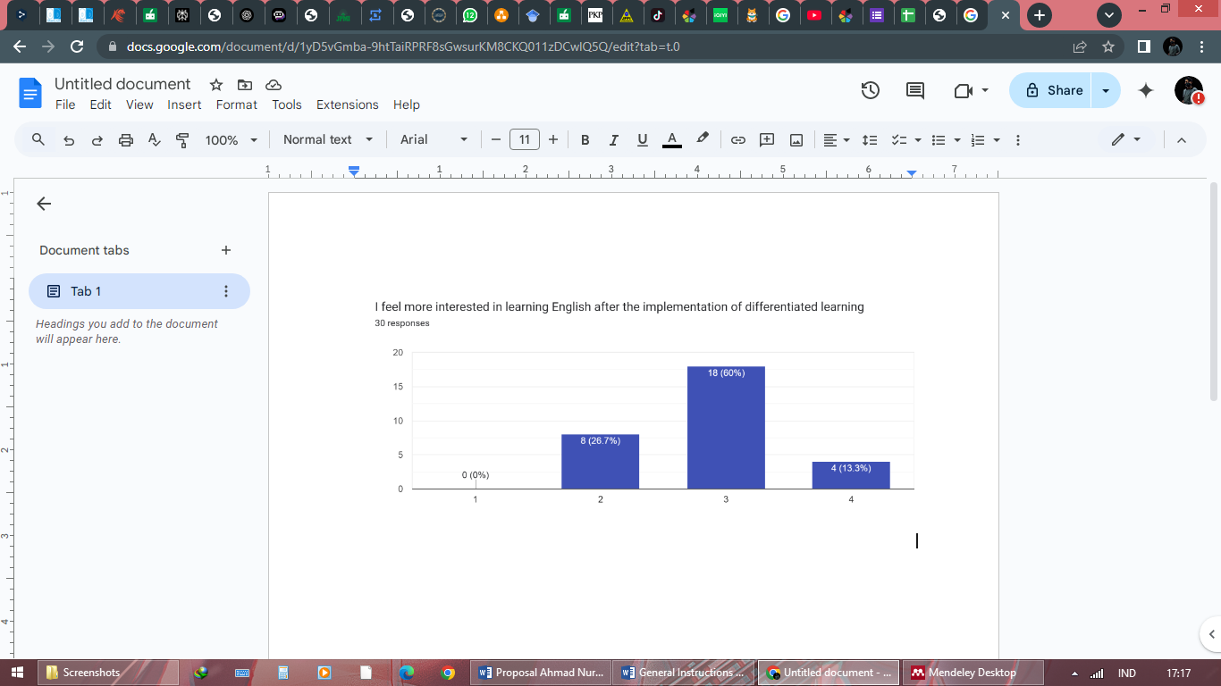

The method of calculating the percentage value is as follows:

Total score obtained

Percentage of Feasibility = X 100%

Total ideal score

Based on the graph above, it can be seen that students who have an interest in learning English subjects are in a very high category, namely 4 students, 18 high school students and 8 students who are included in the category of sufficient learning interest. Then if you add up the total score obtained is 84 and the maximum total score is 90. The learning interest of grade XI students is then expressed as a percentage with the formula of % learning interest equal to the score obtained multiplied by 100% then divided by the maximum score. The calculation results show that the percentage of student learning interest of 93% is classified as "very high" in student learning interest.

According to (Utami, Rahma, and Anggraini 2020) Interest is how much a person is interested in or liked a stimulus or disliked or ignored it. Interest provides a strong drive to do the things he wants. Or according to Reviana, N. (2021) student interest is something that is closely related to the personality, Motivation that exists in students or encouragement from outside influences. The passion that students have to achieve what they want Interest affects talent, and its existence is important for talent development.

Motivations that affect attention, thinking, and performance are better described by the word "interest". More specific findings can be explained according to 4 indicators of learning interest, namely feeling happy, learning interest, showing attention while learning, involvement in learning (Valentina, Rosnaningsih, and Muttaqien 2022). In addition, related to learners' interest in thematic subjects, data shows that the majority of learners enjoy learning about the subject, with 93% of them considered very interested in learning. Based on the results of the interviews, the teacher argued that differentiated learning is a good approach to implement because it meets the needs of students. This is demonstrated by the way learners are actively involved during learning and work together in groups to complete worksheets. In addition, because learning is adjusted to the learning style of students, students' interest in learning increases.

**CONCLUSION**

Based on the research results, it can be concluded that differentiated learning at SMAN 1 Kedungadem is implemented by considering the readiness, interest, learning style, and ability of each student. Teachers provide a wide selection of learning media and methods such as video, audio, and modules so that students can choose the way of learning that best suits their needs. The implementation of this strategy has a positive impact on students' interest in learning English. This is evidenced by the questionnaire results which show that 93% of grade XI students have a very high interest in learning. The increase in interest is supported by flexibility in learning, positive feedback from teachers, and a conducive learning environment. Students become more active, focused and enthusiastic in following the learning process because they feel valued and directly involved. Despite some challenges in its implementation, teachers at SMAN 1 Kedungadem continue to strive to understand students' individual characteristics and adjust learning to be more effective and student-centred. This approach is in line with the principles of Merdeka Curriculum, which emphasises personalised, inclusive, and adaptive learning to the needs of learners.

**THANKS**

The author expressed his gratitude to the Principal and teachers of SMAN 1 Kedungadem for providing permission and support during the research process. Gratitude was also conveyed to students in grades XI-7 who were willing to become respondents and actively participated in filling out the questionnaire. Not to forget, the author appreciates the guidance and direction from the supervisor and the Faculty of Language and Arts Education IKIP PGRI Bojonegoro who have contributed to the preparation of this article. Hopefully the results of this research can provide benefits for the world of education, especially in the development of adaptive and student-centered learning strategies.

**REFERENCE**

Ariyani, Anisa Agus. 2024. “Implementasi Pembelajaran Diferensiasi Terhadap Minat Belajar Bahasa Inggris SMP N 3 Pleret,” 795–800.

Fiantika, Wasil M, Jumiyati, Honesti, Wahyuni, Jonata, Et.al. 2022. *Metodologi Penelitian Kualitatif. In Metodologi Penelitian Kualitatif*. *Rake Sarasin*. https://scholar.google.com/citations?user=O-B3eJYAAAAJ&hl=en.

Herwina, Wiwin. 2021. “Optimalisasi Kebutuhan Murid Dan Hasil Belajar Dengan Pembelajaran Berdiferensiasi.” *Perspektif Ilmu Pendidikan* 35 (2): 175–82. https://doi.org/10.21009/pip.352.10.

Purba, Mariati, Nina Purnamasari, Sylvia Soetantyo, Irma Rahma Suwarma, and Elisabet Indah Susanti. 2021. *Prinsip Pengembangan Pembelajaran Berdiferensiasi (Differentiated Instruction)*. *Pusat Kurikulum Dan Pembelajaran Badan Standar, Kurikulum, Dan Asesmen Pendidikan Kementerian Pendidikan, Kebudayaan, Riset, Dan Teknologi*.

Reviana, N. (2021). The Students’interest In Learning Four Basic English Skills Through Instagram Application. *Edutama*.

Sugiono. 2020. *Metodologi Penelitian Kuantitatif, Kualitatif Dan R & D*.

Utami, Wahyuni Desti, Salsa Bila Rahma, and Indah Ayu Anggraini. 2020. “Analisis Minat Dan Bakat Peserta Didik Terhadap Pembelajaran.” *Jurnal Pendidikan Dan Pembelajaran Dasar* 7 (1): 23–28. http://ejournal.radenintan.ac.id/index.php/terampil/index%0ATerampil:

Valentina, Febi Ria, Asih Rosnaningsih, and Nurul Muttaqien. 2022. “Analisis Minat Belajar Siswa Dalam Mata Pelajaran Bahasa Inggris Siswa Kelas III Di SDN Karawaci Baru 4.” *Jurnal Pendidikan Dan Konseling* 4 (5): 2112–24.